Testing Instructions for dl.dell.com

1. Preparing for Testing:
   1. You MUST HAVE ADMIN ACCESS to your computer
   2. You MUST NOT BE CONNECTED to DELL in anyway
   3. Close All your browsers before proceeding
2. Setting up your host file to Spoofing Akamai Staging:
3. The first step is to setup your workstation to ensure that you are able to easily get an optimized page.

This usually requires “spoofing” your hosts file to a specific IP address.

The hosts file on your machine allows us to force a request to a specific IP address instead of through DNS resolution.

Open a command prompt and ping this e28.dsce4.akamaiedge-staging.net

1. 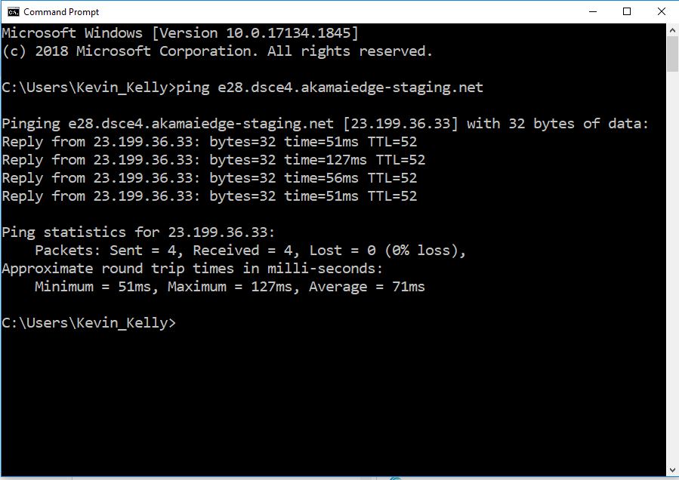
   1. Copy the IP address that is returned – in this case 23.199.36.33
   2. Open Notepad in Admin mode and Edit your hosts file. This can be found at C:\Windows\system32\drivers\etc\hosts
   3. Add the line: *x.x.x.x* www.dl.dell.com where x.x.x.x is the IP address returned from the above nslookup. Example: 23.199.36.33 dl.dell.com
   4. Save the file in the C:\Windows\system32\drivers\etc\directory.
2. Testing your host file setup:
   1. Open a CMD prompt and enter the following command: Ping dl.dell.com.
   2. This should return the IP address that you put in your host file.
3. You are ready to test!

--------------------------------------------------------------------------------------------

104.81.192.54 dl.dell.com

<https://www.dell.com/support/home/en-in/product-support/product/appsync/docs> - videos (dl.dell.com)

<https://www.dell.com/support/home/en-in/product-support/product/networker/docs>

<https://www.dell.com/support/home/us/en/04/product-support/product/vxrail-software/docs>

VxRail 7.0.x Support Matrix - An error occurred while processing your request. Reference #30.3ca93017.1611834307.a27093  
<https://www.dell.com/support/home/us/en/04/product-support/product/networker-module-for-microsoft/docs>  
<https://www.dell.com/support/home/us/en/04/product-support/product/vnx5400/docs>  
<https://www.dell.com/support/home/us/en/04/product-support/product/solutions-enabler/docs>  
<https://www.dell.com/support/home/us/en/04/product-support/product/avamar-server/docs>  
<https://www.dell.com/support/home/us/en/04/product-support/product/recoverpoint-for-virtual-machines/docs> - videos (dl.dell.com)  
<https://www.dell.com/support/home/us/en/04/product-support/product/data-protection-advisor/docs> - videos (dl.dell.com)

<https://www.dell.com/support/home/en-in/product-support/product/xtremio-x1/docs> - videos (dl.dell.com)

<https://www.dell.com/support/home/en-in/product-support/product/atmos-generation-3-hardware/docs>

Atmos G3 Hardware Series Guid - An error occurred while processing your request. Reference #30.3ca93017.1611834307.a27093

<https://dl.dell.com/content/docu97739_VxRail_7.0.x_Support_Matrix.pdf?language=en_US>

<https://dl.dell.com/content/docu44717_Atmos_G3_Hardware_Series_Guide.pdf?language=en_US>

<https://dl.dell.com/content/docu100968_PowerFlex_3.5.1.1_Release_Notes.pdf?language=en_US>

LDELL dl.dell.com (Manuals & Docs)

<https://www.dell.com/support/home/en-in/product-support/product/wyse-5280-mobile-thin-client/docs>

<https://www.dell.com/support/home/en-in/product-support/product/latitude-7204-laptop/docs>

<https://www.dell.com/support/home/en-in/product-support/product/latitude-13-7380-laptop/docs>

<https://www.dell.com/support/home/en-in/product-support/product/alienware-17-r3/docs>

<https://www.dell.com/support/home/en-in/product-support/product/xps-12-9250/docs>

<https://www.dell.com/support/home/en-in/product-support/product/inspiron-22-3277-aio/docs>

<https://www.dell.com/support/home/en-in/product-support/product/xps-8920-desktop/docs>

Coveo source verification for ‘EMC Documentation’

<https://www.dell.com/support/home/us/en/04/product-support/product/networker-module-for-microsoft/docs>  
<https://www.dell.com/support/home/us/en/04/product-support/product/vnx5400/docs>  
<https://www.dell.com/support/home/us/en/04/product-support/product/solutions-enabler/docs>

<https://www.dell.com/support/home/us/en/04/product-support/product/data-protection-advisor/docs>

<https://www.dell.com/support/home/en-in/product-support/product/xtremio-x1/docs>

<https://www.dell.com/support/home/en-in/product-support/product/networker/docs>

<https://www.dell.com/support/home/en-in/product-support/product/unity-500f/docs>

Unity ESRS Pre-installation requirements

Dell EMC Unity CRU: How to Replace an SFP

data-protection-advisor, xtremio-x1, networker